Northwestern Lehigh
Design Develop

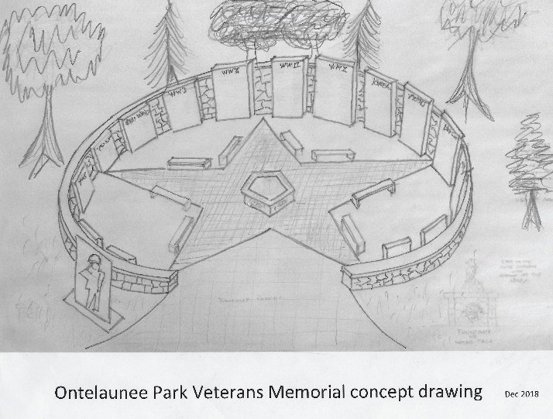
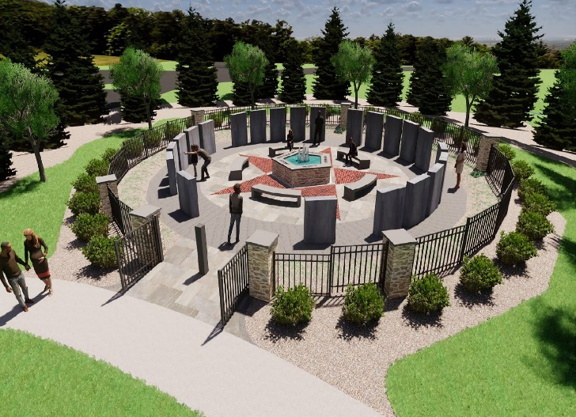

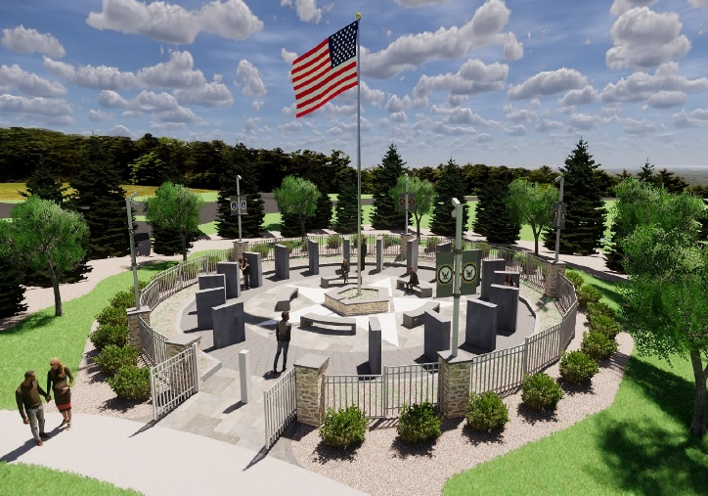

Veterans Memorial
ment Progress

December, 2018 - Original concept sketch brought to the Memorial Committee.
The sketch was used to begin discussion about what the memorial would look like and develop estimated costs for its construction.

January, 2020 - Professional rendering of the memorial concept by Chris Brown, Land Develop Architect, contracted as design and construction consultant in January 2020.

February, 2020 - Rendering by Brown Design showing the committee’s suggestions to change the star from red to white, set the panels in a “spoked” orientation and add the American flag.

February 2020

